Mazel Tov Daniel!

Congratulations on your Bar Mitzvah, you learned about your Jewish heritage, celebrated with friends and family and may be in possession of some gift money!

This letter is your invitation to a very special present, the Bar Mitzvah Money Workshop. In this workshop you will learn how money works, how investors are able to grow their savings and how you can do more with your Bar Mitzvah gift money than you ever thought possible.

Once the party is over and all the presents are unwrapped, this is the gift that will keep on giving!
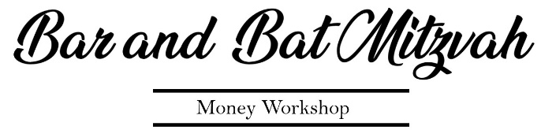

Begin your life changing journey here -> www.thestockboss.com/start
Password – MazelTov (it is case sensitive)

A message for you from the Friedman Family
Insert personal note here
Dear Daniel,
Congratulations! Your bat mitzvah marks a huge accomplishment—but it’s only the beginning of what a young man like you is going to achieve. We chose this gift to help you on your road to success.

For questions about the Money Workshop or support, contact – Malcolm@thestockboss.com

